**Ayush Patel**

**Batch 13 class A**

**Enrolment: CS32**

**EXPERIMENT NO:-7**

* **AIM:** To design and test Magnitude comparator.
* **APPARATUS:** Magnitude comparator Trainer, jumpers IC’s.

* **THEORY:**

The 1 bit magnitude comparator is a combinational circuit that compares magnitude of two 4 bit numbers to make either of its O/P (A>B, A=B, A<B) at logic high level. Let A=A0 & B= B0 are 1-bit number respectively. The 1-bit magnitude comparator compares magnitudes as per following expressions for outputs.

Let xi will be at logic high level when Ai & Bi are at equal level. (i= 0, 1)

* CIRCUIT DIAGRAM OF 2-BIT MAGNITUDE COMPARATOR**:**

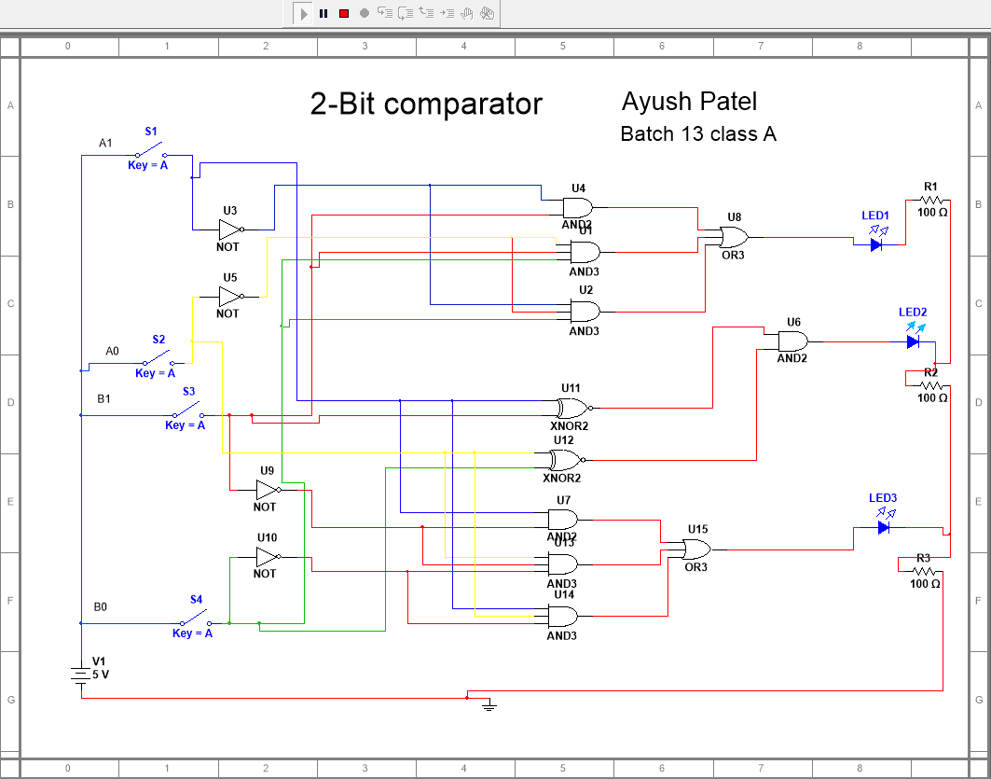

* TRUTH TABLE

|  |  |  |  |  |  |  |
| --- | --- | --- | --- | --- | --- | --- |
| A1 | A0 | B1 | B0 | A>B | A=B | A<B |
| 0 | 0 | 0 | 0 | 0 | 1 | 0 |
| 0 | 0 | 0 | 1 | 0 | 0 | 1 |
| 0 | 0 | 1 | 0 | 0 | 0 | 1 |
| 0 | 0 | 1 | 1 | 0 | 0 | 1 |
| 0 | 1 | 0 | 0 | 1 | 0 | 0 |
| 0 | 1 | 0 | 1 | 0 | 1 | 0 |
| 0 | 1 | 1 | 0 | 0 | 0 | 1 |
| 0 | 1 | 1 | 1 | 0 | 0 | 1 |
| 1 | 0 | 0 | 0 | 1 | 0 | 0 |
| 1 | 0 | 0 | 1 | 1 | 0 | 0 |
| 1 | 0 | 1 | 0 | 0 | 1 | 0 |
| 1 | 0 | 1 | 1 | 0 | 0 | 1 |
| 1 | 1 | 0 | 0 | 1 | 0 | 0 |
| 1 | 1 | 0 | 1 | 1 | 0 | 0 |
| 1 | 1 | 1 | 0 | 1 | 0 | 0 |
| 1 | 1 | 1 | 1 | 0 | 1 | 0 |

* **PROCEDURE:**

1. Connect VCC pin to +5V supply.
2. Connect output signals A>B, A<B and A=B to output LED indicators.
3. Apply any digital input at A-inputs by high/low data switches.
4. Apply any digital input at B-inputs by high/low data switches.
5. Observe output at O/P LED indicators.
6. Repeat above procedure for different A & B inputs & observe the outputs

➢ **CONCLUSION:**

A 2-bit comparator compares two binary numbers, each of two bits and produces their relation such as one number is equal or greater than or less than the other.